**HTML CODE**

<html>

<head>

<link rel="stylesheet" href="format.css">

<title> Fundamentals of ICT lab</title>

</head>

<body>

<p> <h1>Junaid Qadir </h1></p>

<u><p><h3><i>Assistant professor <br>

School of Electrical Engineering and Computer science (SEECS) <br>

Natinal University of Sciences and Technology (NUST) <br> </p> </u>

<a href="https://www.nu.edu.pk/">University website </a> </i></h3>

</body>

<img src="fast.jpg">

</html>

**CSS Code**

h1 {

font-family: verdana,helvetica,sans serif;

font-weight: bold;

font-size: 16pt;

}

**HTML OUTPUT**

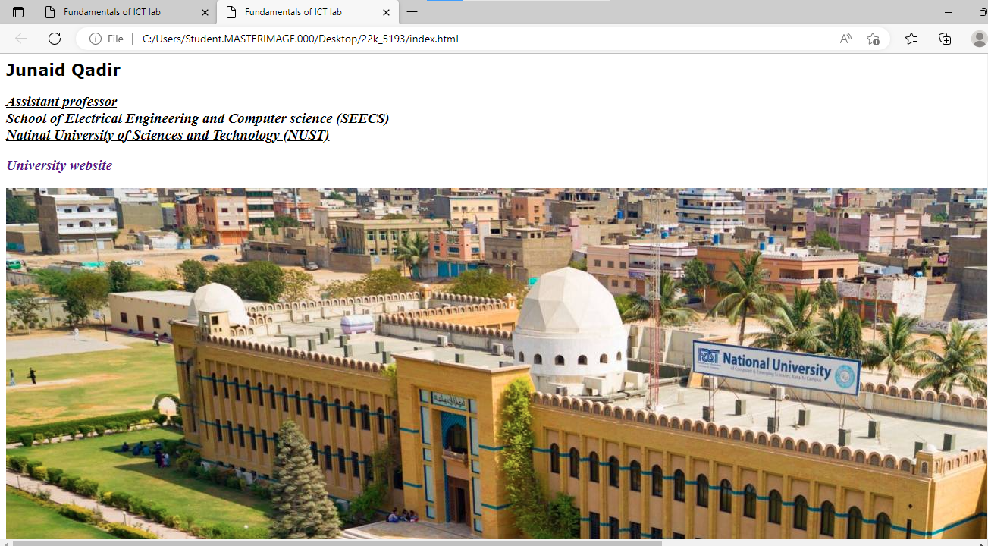

**Java Script code**

<html>

<script>

var username;

username= prompt("What is your name");

alert("Assalamu Alaykum Sir " + username);

alert(username + ", Hope you are doing well~");

</script>

<html>

**Javascript Output**

